Chhun Senghak

Web A 2024

Homework

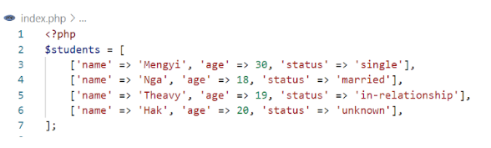

Q1. Write code to display the number of SINGLE students

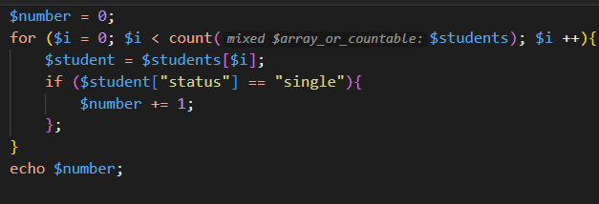

Q2. Write code to display the name of the youngest student

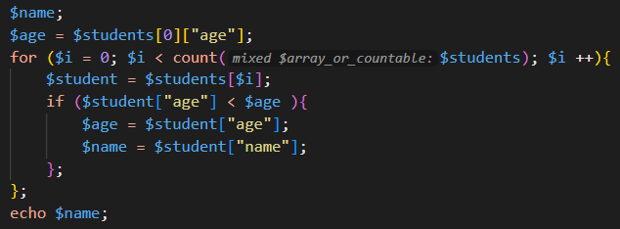

Q3. Write code to display the name of student who are single and between 25 and 30 year olds

